Fast API

What is Fast API?
Fast API is a modern, high-performance web framework in Python that helps
developers create APIs (Application Programming Interfaces) quickly and efficiently.
It uses standard Python type hints to make coding easier and safer for developers.
Fast API automatically handles data validation, serialization, and documentation for
your APIs.
Example:
If we go to a restaurant and we will become a customer and we will call waiter and will say an order and the waiter goes to the kitchen and tell the order to cook and the cook will go to the ingredient store get all the ingredients that he require to cook that recipe and will come back to kitchen and cook the recipe and after completing he will give to waiter and the waiter serve the order to customer.
Hear The waiter playing as an intermediate role and the waiter become as an API.
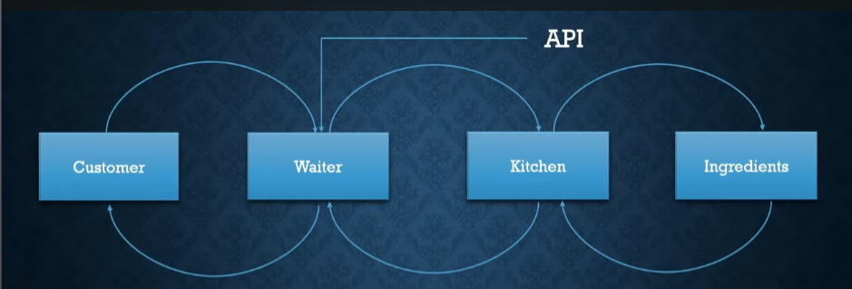
API is who take care and intermediate for all the communication.
How Fast API works in Backend:
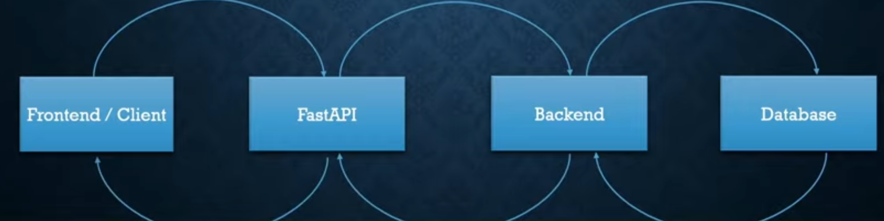
Why Fast API is Popular? (Benefits)
- Super-Fast Performance:
Fast API is one of the fastest python frameworks available, comparable to frameworks like Node.js and Go – thanks to its asynchronous capabilities.
- Easy to Learn & Use:
Even beginners can start building APIs quickly because FastAPI uses clean, redable code and python’s standard features.
- Automate API Documentation:
It automatically generates interactive API documentation (Swagger UI and ReDoc) from our code.
It shows all available endpoints with description and allows testing API routes without writing extra documentation ourself.
- Type-Hint-Based Validation:
FastAPI uses Python type hints for data validation – this means our API checks incoming data automatically, preventing many bugs early on.
- Async Support:
Built-in support for Python’s async/await allows handling many requests at the same time.
Fast API Vs Other Frameworks
Features | Flask | Django | Fast API
Speed | Moderate | Partial | Very Fast
Async Support | No | Partial | Yes
Automatic Docs | No | No | Yes
Validation Built-in | No | No | Yes
Easy to Use | Yes | Moderate | Very Easy

Key Takeaways
- It is Fast, moderate python framework from building APIs.
- It’s easy to learn and perfect for both beginners and professionals.
- It auto-generates interactive docs.
- It uses python type hints make your code safer and cleaner.
- We can run our app using Uvicorn.
Uvicorn is server framework used to run our server.

What is Routing in Fast API?
Routing means connecting URL (web address) with python function.
In Fast API, routes are defined using decorators.
Like:
- @app.get () – handles GET requests.
- @app.post () – handles POST requests.
- @app.put () – handles updates.
- @app. delete () – handles delete.
These are HTTPS Requests methods and decide how users will interact with our API. Example: GET is usually for fetching data, and POST is usually for sending (creating) new data.

What are HTTP Methods?
HTTP Methods | Purpose
GET | Read or fetch data.
POST | Create new data.
PUT | Update existing data.
DELETE | Remove data.

Path Parameters: Dynamic URLs
Path Parameters let us capture values directly from the URL. They are the parts of the path inside {} To use Path parameters we must use.
Send any Value, data dynamically through the URL we must use Path Parameters.

Query Parameters: Optional Extra Info
Query Parameters are values that come after a ? in the URL. They are often used for things like filters or pagination.
For this there is no need of using {} in our code. Simply in the URL we must put a ? pass our value.

Practical
To test our API, we can use Postman etc. But Fast API is providing UI Based tester and it is called as Swagger UI and to access this we just have to type /docs in our app URL in the browser.

CURD Operations Practical
Refer to GitHub

Database Connection in Fast API SQL Alchemy

SQL Alchemy ORM – A powerful python library that lets us to work with database using python classes instead of writing raw SQL queries. Fast API doesn’t force us to use any one database but SQL Alchemy is one of the most common and flexible choice.
When we are working with SQL database the best choice is to use SQL Alchemy.
Why Use a Database with Fast API?
Database let our API persist data – so the data stays even after our app restarts.
With database we can:
- Save Users
- Store applications data
- Run queries and filters
- Build real-world applications
We will use SQL Alchemy ORM (Object Relational Mapper) so we can treat database tables as python classes and rows as objects.
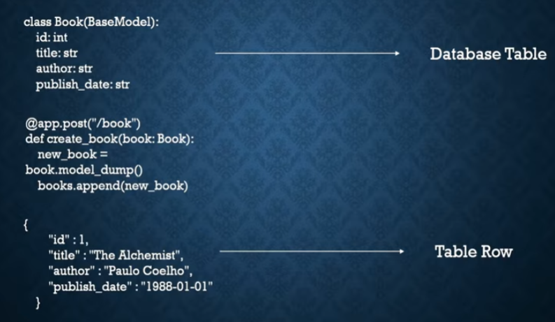

What is ORM And Why We Use It?
ORM (Object Relational Mapper) lets us interact with databases using python objects instead of SQL – easier and less error-prone.
- We define python classes (modules) and SQL Alchemy converts them into SQL.
- It makes our Fast API code cleaner and more pythonic.
Practical
Refer to this Repo: GitHub SQL

Fast Api Authentication

What is Authentication vs Authorization?
Authentication
This is the process of verifying who a user is – usually through login system like (Email + Password). Only authenticated users only can access certain parts of our API.
Authorization
After Authentication, authorization determines what the authenticated user is allowed to do – e.g. regular user or admin user or something else.

Example
Authentication: User Proves they are User 123.
Authorization: User 123 can view only their data and not allowed to delete other tables.

What & Why to Use JWT (JSON Web Tokens)?
- JWT stands for JSON Web Token – a compact token sent by clients to prove they are Authenticated.
- Tokens are Signed with secret Key, so the server can verify they haven’t been tempered with.
- No server-side session storage is needed – everything needed to verify is inside the token.
How JWT Works:
- User logs in with credentials.
- Server verifies login and generates a JWT token.
- Client includes this token in the authorization header for future requests.
- Server checks token validity before responding.
- This pattern makes scalable and stateless authentication possible.
Components Needed for Auth in Fast API
When we are building a login and protected routes in Fast API, we typically use:
- OAuth2 with Password Flow and Bearer Token
Fast API supports this flow and integrates with JWT tokens.
- JWT Token Generation Libraries like python-jose or PyJWT. This help create and validate signed tokens.
- Password Hashing Library like passlib[argon2]. Passwords must be stored securely (not in plain text).

How OAuth2 Password Flow works in Fast API
Fast API uses OAuth2 with password and Bearer tokens:
- The client sends username + password to login endpoint.
- Server checks credentials.
- Server returns a JWT token.
- Client sends the token in an Authorization: Bearer <token> header.
- Fast API checks token before allowing access to protected routes.
User Login Server Create JWT Client Stores Token Client Sends Token
Server Validate Token Access Granted.

Practical
Refer to this Repository: GitHub Authentication

Fast API With Docker

App MySQL Database Table User fastapi app
Now we need to dockarize this flow.

Now we had created this project using requirements .txt and after someday’s I need to another person for testing and during that time he need to install all the libraries manually and also there will be version conflict because during the creation of the project the versions are different and during the resting versions are different. Even the same problems occur when we are trying to deploy in cloud. So, to stop this we have a concept called containerization using docker.
- Manual Installation
- Version Conflict
- Crashing.

Keeping all our codes in a single container is called containization. And we freeze them all and then we create one image.
When we send the image to another person then he will pull this image data and he is going to get all the same version that we had worked on.
After this there won’t be:
- Manual Installation
- Version Conflict
- Crashing
Steps for Dokerization:
- Docker file: Steps of instructions that how docker need to create an image.
- Docker-compose.yml file: fast api app ++ MySQL 2 different container services.

Orchestrate into single Yml file.
We need to mention all our services.
- Create an image
- Push to docker Hub.

Practical
Refer to this Repository: GitHub

